‘Lifeline’ - Blood and Plasma Donation Website

### PREPARED FOR

CSE300 - Software Engineering

School of Engineering and Applied Science, Ahmedabad University

### PREPARED BY

Group 5:

|  |  |
| --- | --- |
| **Group Members:** | |
| Shivani Kadam (AU1841133) | Dishita Madani (AU1841112) |
| Aisha Nagrecha (AU1841137) | Yesha Ajudia (AU1841078) |
| Manasvi Dobariya (AU1841053) | Kartavi Baxi (AU1841079) |
| Darshak Chavda (AU1841063) | Nisarg Thoriya (AU1841142) |

Index

**1. Introduction** **6**

**1.1 Purpose 6**

**1.2 Scope 6**

**1.3 Definitions, acronyms, and abbreviations 6**

**2. Overall Description 7**

**2.1 Product perspective 7**

**2.2 Product features 7**

**2.3 User characteristics 7**

**2.4 General Constraints 8**

**2.5 Design Constraints 8**

**2.6 Assumptions and Dependencies 8**

**3. Specific Requirements 9**

**3.1 External Interface Requirements 9**

**3.1.1 User Interfaces 9**

**3.1.2 Hardware Interfaces 9**

**3.1.3 Software Interfaces 9**

**3.2 Functional Requirements 9**

**3.2.1 Login/Sign up 9**

**3.2.1.1 Purpose of the System 9**

**3.2.1.2 Stimulus and Response 10**

**3.2.1.3 Associated Functional Requirements 10**

**3.2.2 Dashboard 10**

**3.2.2.1 Purpose of the System 10**

**3.2.2.2 Stimulus and Response 10**

**3.2.2.3 Associated Functional Requirements 10**

**3.2.3 Request Blood 10**

**3.2.3.1 Purpose of the System 10**

**3.2.3.2 Stimulus and Response 11**

**3.2.3.3 Associated Functional Requirements 11**

**3.2.4 Donate Blood 11**

**3.2.4.1 Purpose of the System 11**

**3.2.4.2 Stimulus and Response 11**

**3.2.4.3 Associated Functional Requirements 11**

**3.2.5 Track Application 11**

**3.2.5.1 Purpose of the System 11**

**3.2.5.2 Stimulus and Response 11**

**3.2.5.3 Associated Functional Requirements 12**

**3.2.6 About Us 12**

**3.2.6.1 Purpose of the System 12**

**3.2.6.2 Stimulus and Response 12**

**3.2.6.3 Associated Functional Requirements 12**

**3.2.7 Contact Us 12**

**3.2.7.1 Purpose of the System 12**

**3.2.7.2 Stimulus and Response 12**

**3.2.7.3 Associated Functional Requirements 12**

**3.2.8 Why Donate Blood 12**

**3.2.8.1 Purpose of the System 12**

**3.2.8.2 Stimulus and Response 13**

**3.2.8.3 Associated Functional Requirements 13**

**3.2.9 Register / Login Hospital 13**

**3.2.9.1 Purpose of the System 13**

**3.2.9.2 Stimulus and Response 13**

**3.2.9.3 Associated Functional Requirements 13**

**3.2.10 Post Event 13**

**3.2.10.1 Purpose of the System 13**

**3.2.10.2 Stimulus and Response 13**

**3.2.10.3 Associated Functional Requirements 14**

**3.2.11 Update Applications 14**

**3.2.11.1 Purpose of the System 14**

**3.2.11.2 Stimulus and Response 14**

**3.2.11.3 Associated Functional Requirements 14**

**3.2.12 Show Appointments 14**

**3.2.12.1 Purpose of the System 14**

**3.2.12.2 Stimulus and Response 14**

**3.2.12.3 Associated Functional Requirements 14**

**3.2.13 My Requests 14**

**3.2.13.1 Purpose of the System 14**

**3.2.13.2 Stimulus and Response 14**

**3.2.13.3 Associated Functional Requirements 15**

**3.3 Non Functional Requirements 15**

**3.3.1 Performance Requirements 15**

**3.3.2 Safety Requirements 15**

**3.3.3 Security Requirements 15**

**3.3.4 Software Quality Attributes 16**

**4. Diagrams 16**

**4.1 Use-case diagram 16**

**4.2 ER-Diagram 17**

**4.3 Data flow diagram 18**

**4.3.1 Context level-0 18**

**4.3.2 Level-1 DFD 19**

**4.3.3 Level-2 DFD 20**

**4.4 Sequence diagram 22**

**4.4.1 User interface - Regular donor 22**

**4.4.2 User interface - Emergency donor 23**

**4.4.3 User interface - Receiver 24**

**4.4.4 Hospital interface 25**

**4.4.5 System 26**

# 1. Introduction

**1.1 Purpose**

This website ‘Lifeline’ aims to provide its users a simpler and easier way to donate blood and plasma. The purpose of this section is to provide the reader with the general background of the information and an insight about the web application “Lifeline - A Blood and Plasma Donation website”. This document explains the purpose and features of the system and the constraints under which it should operate. It also specifies the domain, functional and non-functional requirements that are essential for the successful use of this application by its customers.

**1.2 Scope**

This website ‘Lifeline’ is basically made by the students of Ahmedabad University as a part of their project. It can be applicable at University as well as National level. The main objective of this project is to simplify the process of blood and plasma donation for the users as well the hospitals.

With the help of this application, it helps the users to save more time. In the current situation of pandemic, it is very vital if any single person could donate blood and save a life. We see that the deaths are increasing every day like never before. Many people are willing to help the needy by making their donation. So, to save time, this application bridges the gap between users and the hospital. The user can register for doing donation and receiving the donation using the website.

**1.3 Definitions, acronyms, and abbreviations**

HTML - HyperText Markup Language

CSS - Cascading Style Sheets

JS - JavaScript

JSON - JavaScript Object Notation

JSX - JavaScript XML

Firebase - Firestore database framework

# 2. Overall Description

**2.1 Product Perspective**

This website ‘Lifeline’ is used to assist its users; for donors to schedule their donation, the receivers can contact the donors and the hospitals as a mediator between the two. The project is connected with the firebase and it stores the data of the user.

**2.2 Product Features**

Lifeline application is built to assist its user to make the entire blood and plasma donation an easier process. It has following features:

1. Donors:

* Make donor profile and donation request
* Fix donation appointment
* Track application
* Emergency donation
* Check Events

1. Receivers:

* Contact donor
* Receiver request
* Check Events
* View donors list

1. Hospitals:

* Register hospital
* Update news and feed
* Accept or Reject any application
* Check Appointments

**2.3 User Characteristics**

Lifeline application is built at a small scale but it can be expanded as an open source application. The current users of the application are hypothetical people. This is to just show the working of the application.

Any user using this application must have basic computer skills. Here are the characteristics of the users:

* The user should have access to the proper device and browser that helps him/her to run the application.
* The user must have a good internet connection to run the application.
* For a donor or receiver, the user should have his/her medical profile
* For hospital, it should have proper admin staff to manage the application from their end

**2.4 General Constraints**

Every system has defined some constraints which should be abided by the users while using the system. Similarly, while building Lifeline applications we have defined some constraints as well. The constraints are as follows:

* All the users should have registered mobile number or email address
* System must be user friendly
* The donors can only donate at the hospitals which are registered
* The donor and receiver should provide legitimate details about their medical history

**2.5 Design Constraints**

Developers should know the technologies which should be used for developing the system. The design must be easy to interpret, user-friendly and up-gradable. The structure of modules must be designed in such a way that it stores data efficiently at the backend.

**2.6 Assumptions and Dependencies**

User, be it donor, receiver or the hospital should have a clear idea of the use case of the software. Since this is a web-application it would be accessible 24/7 except the maintenance period. One must have a good internet connection to use the application. The system also requires the user to be familiar with web browser operations. Users should be able to interact well with the system.

# 3. Specific Requirements

**3.1 External Interface Requirements**

**3.1.1 User Interfaces**

The interface of the website ‘Lifeline’ is very user friendly. It has proper labelled buttons and text fields which ensures that the user can use it easily. With all these, the target users of this software would relatively find it easy to use it. Here’s a list of the UI screens:

* UI-1 - Login screen
* UI-2 - Signup screen
* UI-3 - Home Screen
* UI-4 - Dashboard which shows pending donation, total number of donations done and total application
* UI-5 - Hospital dashboard which shows the number of applications to be approved, total applications and total number of events

**3.1.2 Hardware Interfaces**

To be able to run the web application based Lifeline, the minimum requirements of the hardware are : a computer device that supports a web browser.

**3.1.3 Software Interfaces**

The website ‘Lifeline’ is used to assist its users; for donors to schedule their donation, the receivers can contact the donors and the hospitals as a mediator between the two. Since it is a web application, one would require a computer and active internet connection. Also, the user must have a web browser which would support the latest versions of HTML and CSS.

**3.2 Functional Requirements**

**3.2.1 Login/Sign up**

**3.2.1.1 Purpose of the System**

The application will authenticate the user’s credentials and will log in that user inside the system

**3.2.1.2 Stimulus and Response**

* Stimulus: User will fill his/her login credentials

Response: Open Login page

* Stimulus: User will click on the Login Button

Response: Verify the login credentials at the backend and it redirects to the dashboard

**3.2.1.3 Associated Functional Requirements**

The user will successfully login into the application

**3.2.2 Dashboard**

**3.2.2.1 Purpose of the System**

The application will redirect here after successful login. It would show the details in following way:

* Dashboard which shows pending donation, total number of donations done and total application and upcoming events
* Hospital dashboard which shows the number of applications to be approved, total applications and total number of events and also upcoming events

**3.2.2.2 Stimulus and Response**

* Stimulus: User will be redirected to the screen

Response: See the dashboard

**3.2.2.3 Associated Functional Requirements**

The user will successfully see the details regarding his/her donation

**3.2.3 Request Blood**

**3.2.3.1 Purpose of the System**

The option will show a form which has to be filled by the user for requesting blood

**3.2.3.2 Stimulus and Response**

* Stimulus: User will fill the form

Response: See user’s detail

* Stimulus: User clicks submit button

Response: Application to receive blood will be submitted

**3.2.3.3 Associated Functional Requirements**

Request blood application submitted successfully

**3.2.4 Donate Blood**

**3.2.4.1 Purpose of the System**

The option will show a form which has to be filled by the user for donating blood

**3.2.4.2 Stimulus and Response**

* Stimulus: User will fill the form

Response: See user’s detail

* Stimulus: User clicks submit button

Response: Application to donate blood will be submitted and it’s status will be updated to ‘pending for verification’

**3.2.4.3 Associated Functional Requirements**

Donate blood application submitted to the hospital for further verification

**3.2.5 Track Application**

**3.2.5.1 Purpose of the System**

The application will show the user’s donation application status

**3.2.5.2 Stimulus and Response**

* Stimulus: User will be redirected to the screen

Response: See details about pending donation applications

**3.2.5.3 Associated Functional Requirements**

The user will be able to see the status of his/her pending donation applications status as updated by the hospital

**3.2.6 About Us**

**3.2.6.1 Purpose of the System**

This gives a idea about the application and its developers

**3.2.6.2 Stimulus and Response**

* Stimulus: User will be redirected to the screen

Response: See the details of the website and its developers

**3.2.6.3 Associated Functional Requirements**

The user will successfully see the details regarding website

**3.2.7 Contact Us**

**3.2.7.1 Purpose of the System**

This gives the contact details to whom the users can contact whenever they have a doubt in the working of the web application

**3.2.7.2 Stimulus and Response**

* Stimulus: User will be redirected to the screen

Response: See the contact details

**3.2.7.3 Associated Functional Requirements**

The user will successfully see the contact details regarding website

**3.2.8 Why Donate Blood**

**3.2.8.1 Purpose of the System**

This gives an insight to the user to motivate him/her to donate blood

**3.2.8.2 Stimulus and Response**

* Stimulus: User will be redirected to the screen

Response: See details of why one should donate blood

**3.2.8.3 Associated Functional Requirements**

The user will successfully see the details

**3.2.9 Register / Login Hospital**

**3.2.9.1 Purpose of the System**

The application verifies if the hospital trying to access the system is authentic.

**3.2.9.2 Stimulus and Response**

* Stimulus: Hospital will enter login credentials and click on Login button

Response: It will be redirected to Dashboard

**3.2.9.3 Associated Functional Requirements**

The hospital will be successfully logged in.

**3.2.10 Post Event**

**3.2.10.1 Purpose of the System**

This will show an Add Event page, where the hospital can add an upcoming event along with a picture, a title, and a description of the event.

**3.2.10.2 Stimulus and Response**

* Stimulus: Hospital will add a picture file, and click on upload button

Response: The uploaded file will be visible in the box given

* Stimulus: Hospital will add a title and description and click on Post button

Response: A popup message saying event has been posted successfully and the event is displayed in My Events section

**3.2.10.3 Associated Functional Requirements**

The event will be visible in My Events section

**3.2.11 Update Applications**

**3.2.11.1 Purpose of the System**

This will show pending donation applications, whose status needs to be updated.

**3.2.11.2 Stimulus and Response**

* Stimulus: Hospital will update the application status, i.e., either accept or reject the application.

Response: The status of application will be updated from ‘pending’ to either of ‘accepted’ or ‘rejected’.

**3.2.11.3 Associated Functional Requirements**

The application will shift to ‘Application History’, with updated status

**3.2.12 Show Appointments**

**3.2.12.1 Purpose of the System**

This will display a calendar for selecting a date to see the appointments

**3.2.12.2 Stimulus and Response**

* Stimulus: Select a date for seeing appointments and click on Show Appointments

Response: Appointments for the date selected will be displayed below

**3.2.12.3 Associated Functional Requirements**

The appointments for the selected date will be displayed.

**3.2.13 My Requests**

**3.2.13.1 Purpose of the System**

This will show the user’s requests made for receiving blood

**3.2.13.2 Stimulus and Response**

* Stimulus: User confirms his/her request to receive blood

Response: Request made successfully

* Stimulus: User wants to delete his/her request to receive blood

Response: Request deleted successfully

**3.2.13.3 Associated Functional Requirements**

The application will update the status of receiver’s request at the backend as well if request is made it will be visible to the donor

**3.3 Non Functional Requirements**

**3.3.1 Performance Requirements**

Although the application is simple to use for the donors and receivers, at the same time, the hospital should operate it efficiently. Since it’s about blood and plasma donation, if the hospital makes any mistake while rectifying the donor and receiver’s profile, it could end up taking someone’s life. It should be able to handle all the requests with minimum response time and maximum throughput. Also, the hospitals should have efficient data storage to store the records.

**3.3.2 Safety Requirements**

Different medical information would be entered by the donor and receiver into the database such as blood group, medical conditions, height, weight, etc. Mismanagement of this information from the hospital's end might cause donor and/or receiver dissatisfaction. Also, if either the donor or receiver does not enter the correct information, that could cost someone’s life. That will eventually lead to misunderstandings and make the application inefficient to the users, only because of mistakes on giving or rectifying information.

**3.3.3 Security Requirements**

The web application Lifeline works on the login credential. Therefore, all the users who are eligible to use Lifeline, would have an account on this platform. Therefore, the system always requires a user to identify himself/herself before making or receiving or even verifying any donation. Also, the hospitals would not disclose the identity of the donor unless it’s an emergency donor thus maintaining the information of both the donors and receivers.

**3.3.4 Software Quality Attributes**

The system is easy to use. The main purpose of the application is to save user’s (here the donor, receiver and the hospital) time and the application should be able to fulfill this. The application ought to be robust enough to give smooth user experience while it is being used.

Additionally, the application is able to work on any of the modern browsers like Firefox, Explorer, Chrome, and any of the common Operating Systems like Linux, Windows and Mac OS.

**4. Diagrams**

**4.1 Use-case diagram**

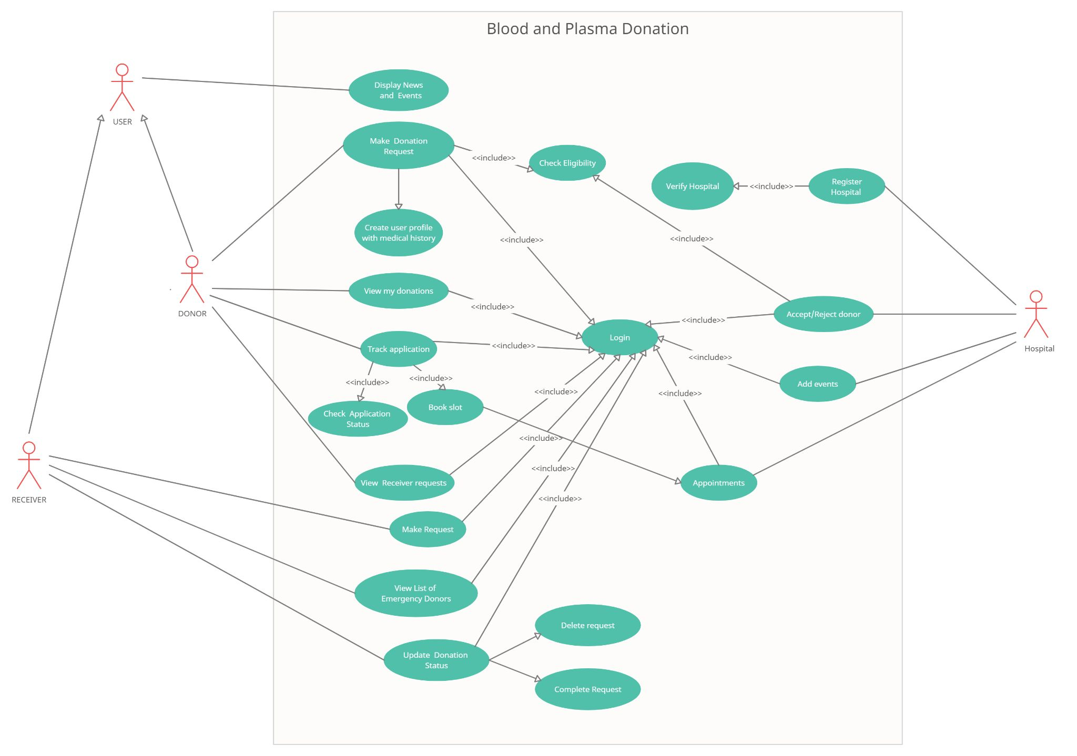

**4.2 ER-diagram**

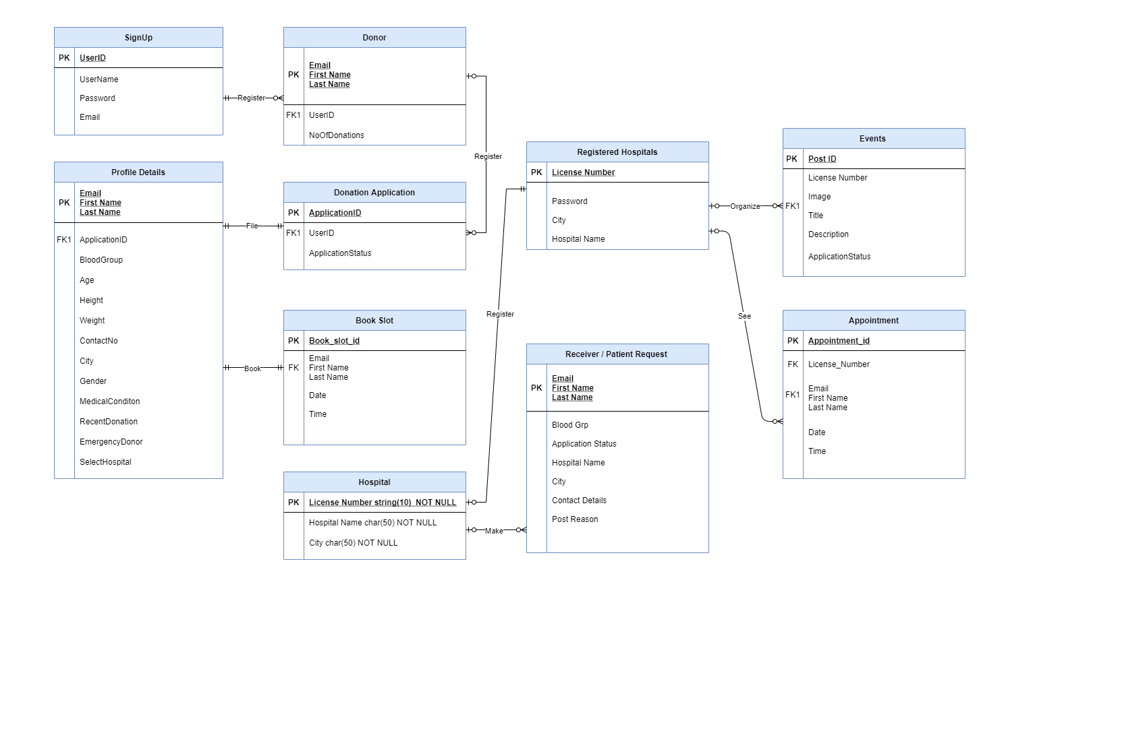

**4.3 Data flow diagram**

**4.3.1 Context level-0**

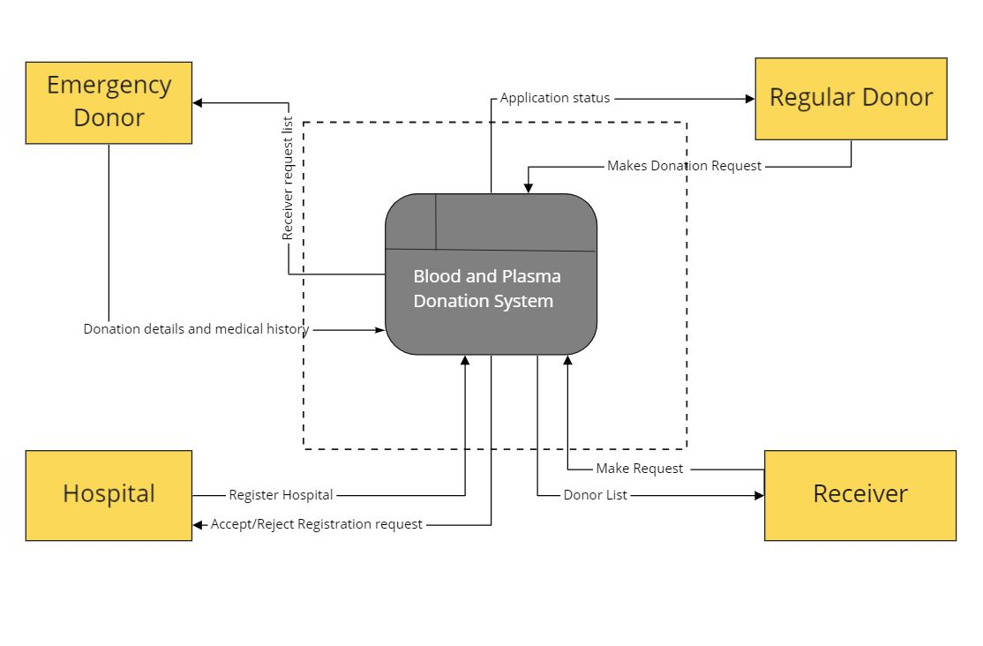

**4.3.2 Level-1 DFD**

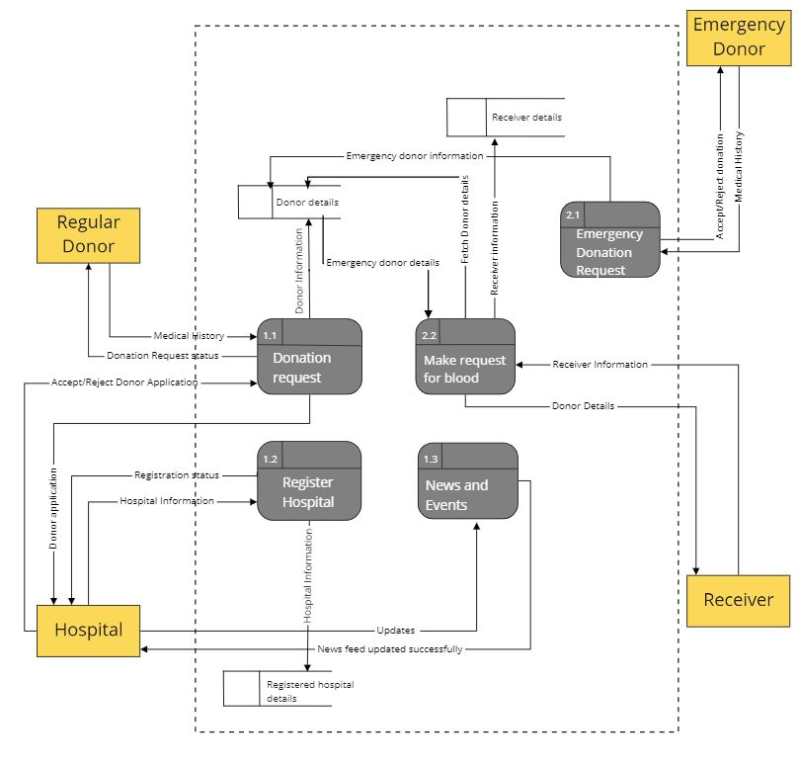

**4.3.3 Level-2 DFD**

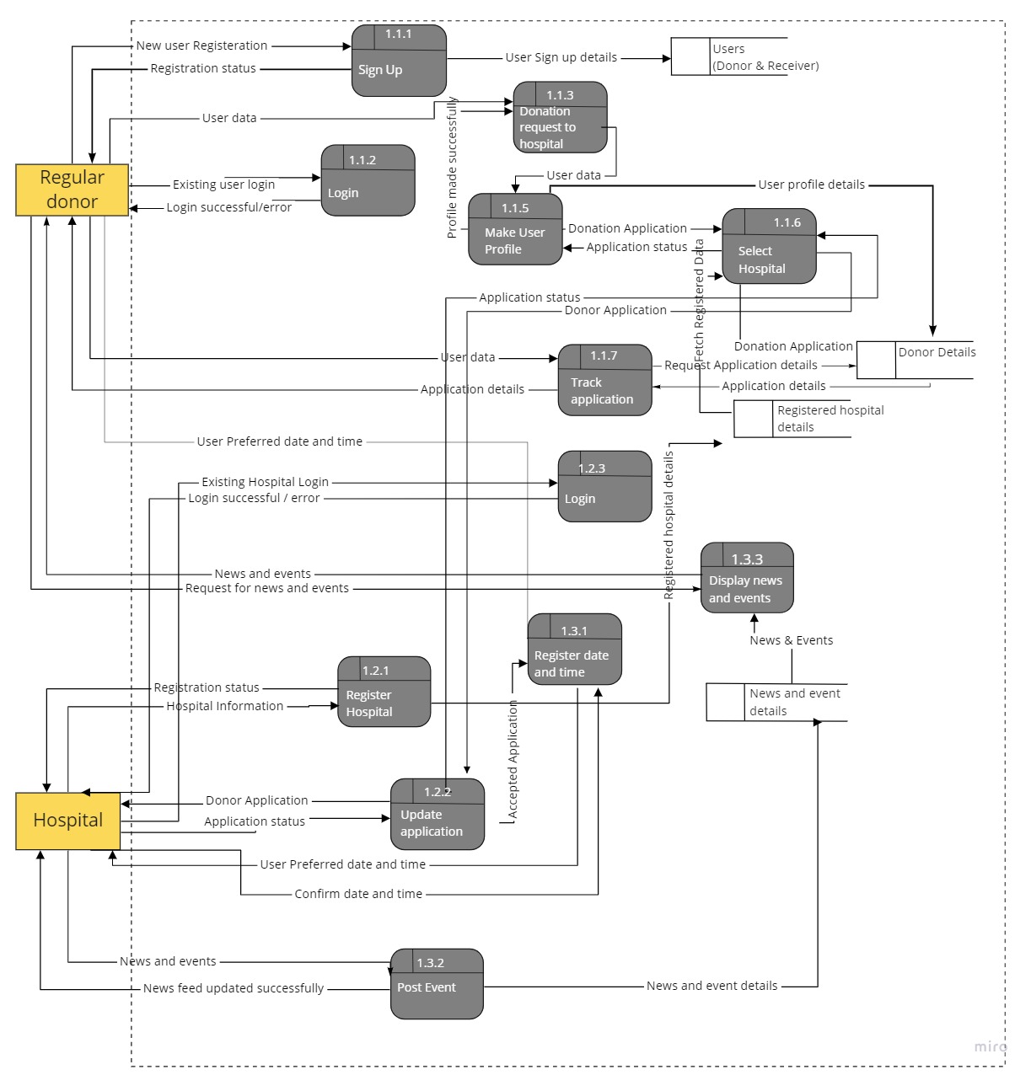

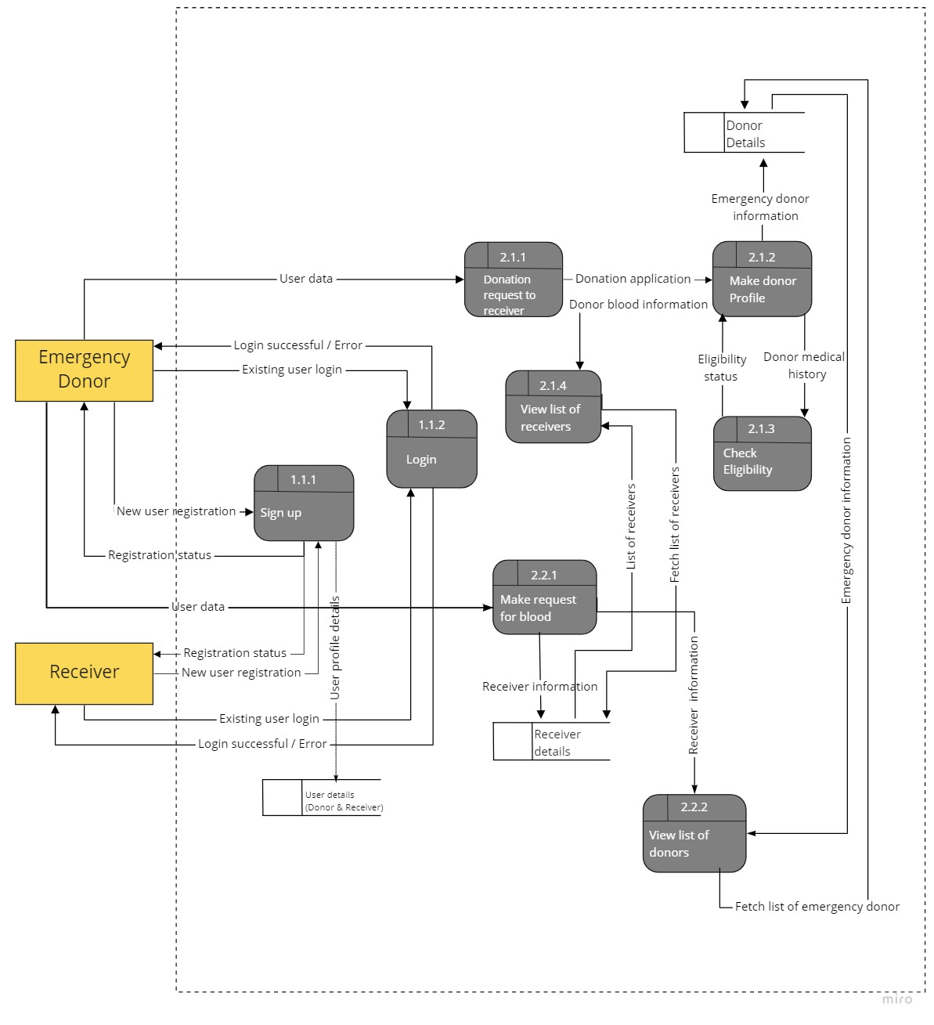

**4.4 Sequence diagram**

**4.4.1 Regular Donor**

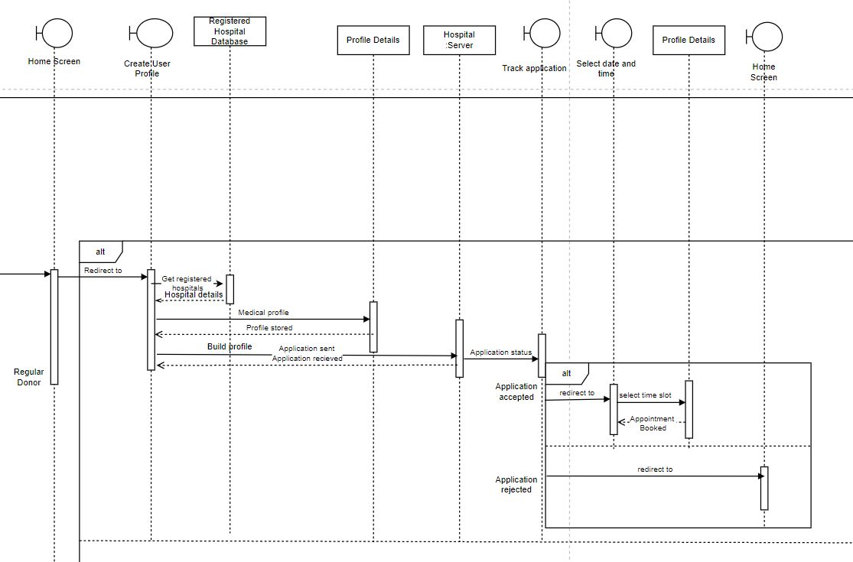

**4.4.2 Emergency Donor**

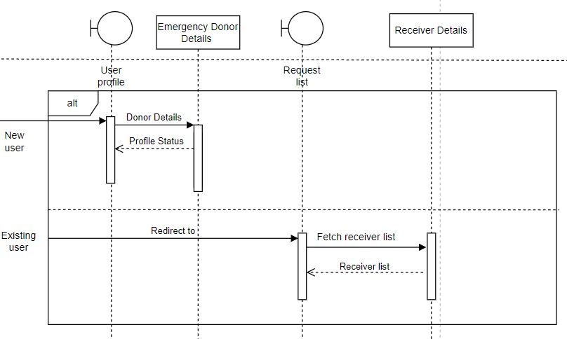

**4.4.3 Receiver**

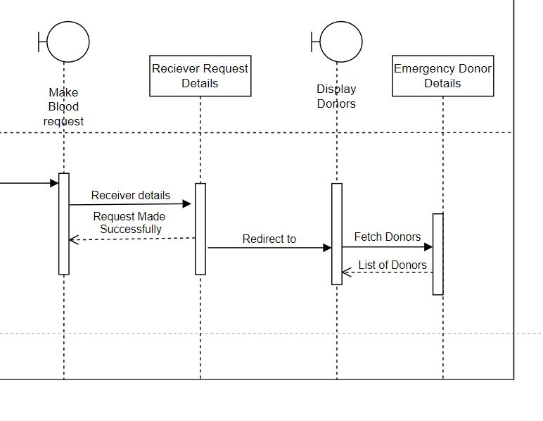

**4.4.4 Hospital**

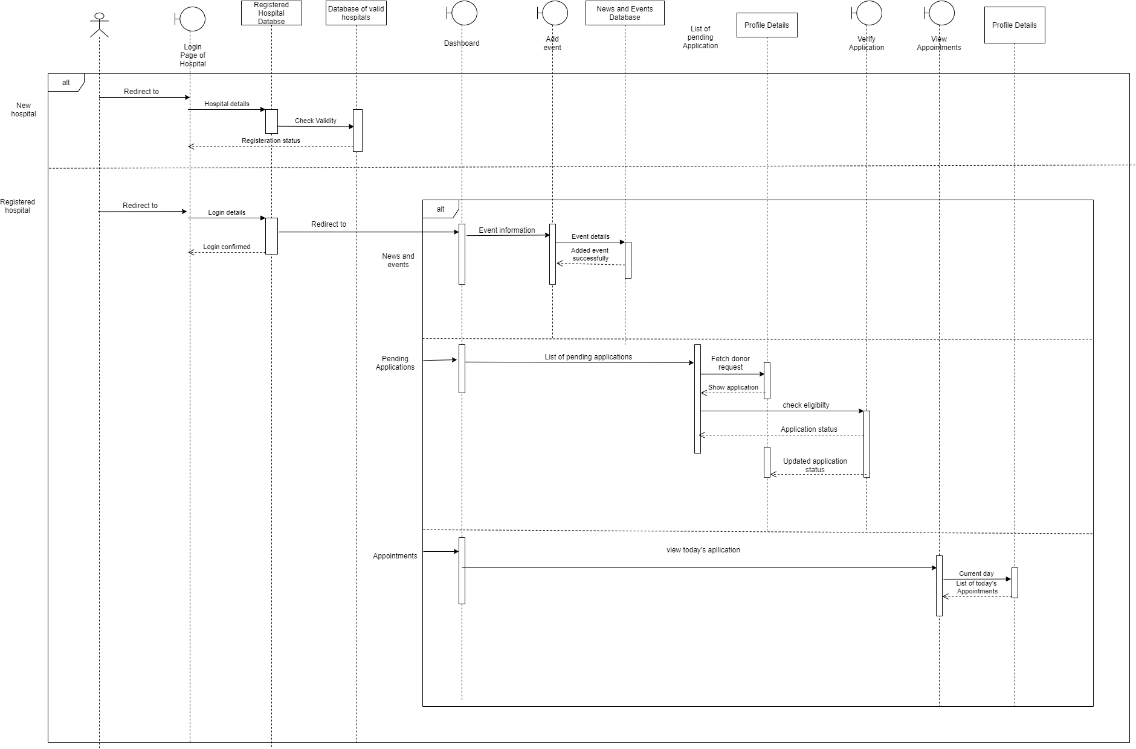

**4.4.5 System**

